REVENUS

[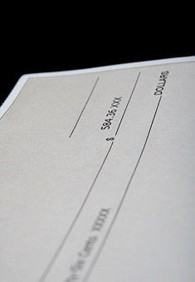](https://pixabay.com/en/american-bills-business-cheque-1239036/)