**ANGLAIS DE BASE POUR SITUATIONS DE LA VIE COURANTE**

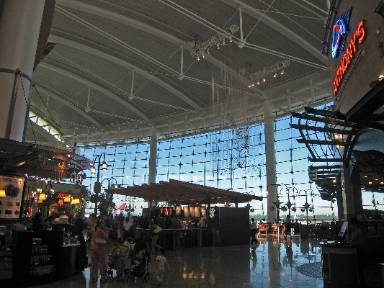

**AIRPORTS**

***Looking for the check-in desk*** :

<http://www.learnenglishfeelgood.com/travelenglish/english-travel-airport1.html>

***At the check-in desk part 1*** :

<http://www.learnenglishfeelgood.com/travelenglish/english-travel-airport2.html>

***At the check-in desk part 2*** :

<http://www.learnenglishfeelgood.com/travelenglish/english-travel-airport3.html>

***What’s wrong (problem that you can have at the airport) :***

<http://www.learnenglishfeelgood.com/travelenglish/english-airport-whats-wrong.html>

***Answers and have to find the question*** :

<http://www.learnenglishfeelgood.com/travelenglish/airport-questions-answers1.html>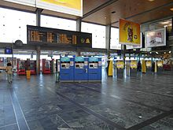

**ON THE PLANE**

***Speaking with flight attendants/passengers part 1*** :

<http://www.learnenglishfeelgood.com/travelenglish/english-travel-airplane1.html>

***Speaking with flight attendants/passengers part 2 :***

<http://www.learnenglishfeelgood.com/travelenglish/english-travel-airplane2.html>

***What’s wrong (problem that you can have in the plane)*** :

<http://www.learnenglishfeelgood.com/travelenglish/english-airplane-whats-wrong.html>

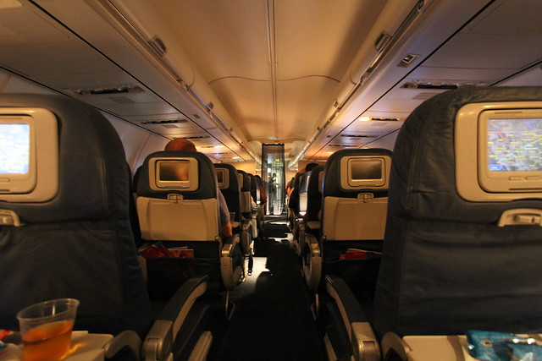

**CUSTOM/IMMIGRATION** 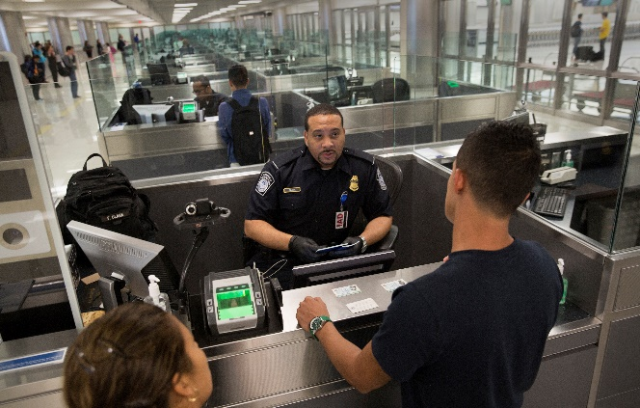

***Entering a country*** :

<http://www.learnenglishfeelgood.com/travelenglish/english-customs1.html>

***Answers and have to find the question*** :

<http://www.learnenglishfeelgood.com/travelenglish/customs-questions-answers1.html>

**HOTELS/ACCOMODATIONS**

***General vocabulary part 1*** :

<http://www.learnenglishfeelgood.com/travelenglish/travel-phrases-hotel-general1.html>

***General vocabulary part 2*** :

<http://www.learnenglishfeelgood.com/travelenglish/travel-phrases-hotel-general2.html>

***Checking in part 1*** :

<http://www.learnenglishfeelgood.com/travelenglish/english-travel-hotel1.html>

***Checking in part 2*** :

<http://www.learnenglishfeelgood.com/travelenglish/english-travel-hotel2.html>

***Getting from the hotel into the city*** :

<http://www.learnenglishfeelgood.com/travelenglish/english-tourism-hotel3.html>

***Talking to someone at the reception desk*** :

<http://www.learnenglishfeelgood.com/travelenglish/english-tourism-hotel4.html>

***Making a reservation*** :

<http://www.learnenglishfeelgood.com/travelenglish/english-tourism-hotel5.html>

***Asking for directions*** :

<http://www.learnenglishfeelgood.com/travelenglish/phrases-for-tourists-hotel6.html>

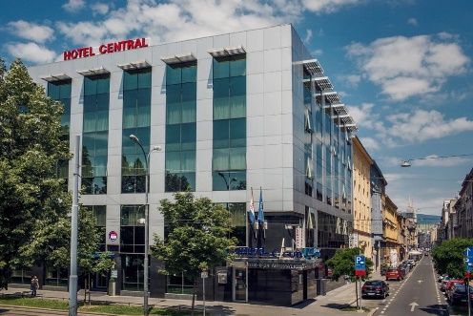

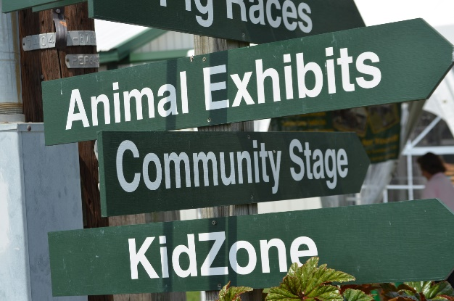 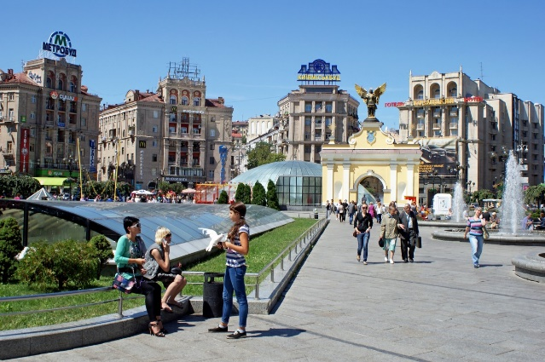

***Talking about what you like/don’t like*** :

<http://www.learnenglishfeelgood.com/travelenglish/hotel-like-dontlike1.html>

***Answers and have to find the question :***

<http://www.learnenglishfeelgood.com/travelenglish/hotel-questions-answers1.html>

**RESTAURANTS/BARS/EATING OUT**

***Getting seated*** :

<http://www.learnenglishfeelgood.com/travelenglish/english-restaurant1.html>

***Ordering part 1*** :

<http://www.learnenglishfeelgood.com/travelenglish/english-restaurant2.html>

***Ordering part 2*** :

<http://www.learnenglishfeelgood.com/travelenglish/english-restaurant3.html>

***Ordering part 3*** :

<http://www.learnenglishfeelgood.com/travelenglish/english-restaurant4.html>

***Eating a meal*** :

<http://www.learnenglishfeelgood.com/travelenglish/english-restaurant5.html>

***Eating/bad service*** :

<http://www.learnenglishfeelgood.com/travelenglish/english-restaurant6.html>

***Finishing a meal/paying*** :

<http://www.learnenglishfeelgood.com/travelenglish/english-restaurant7.html>

***Talking about what you like/don’t like*** :

<http://www.learnenglishfeelgood.com/travelenglish/restaurant-like-dontlike1.html>

***Ordering drinks at the bar*** :

<http://www.learnenglishfeelgood.com/travelenglish/tourism-english-bar1.html>

***Fast food vocabulary*** :

<http://www.learnenglishfeelgood.com/travelenglish/travel-phrases-fastfood1.html>

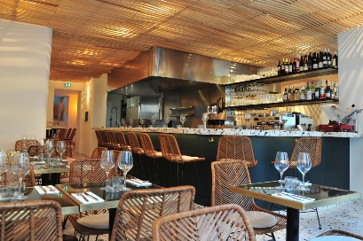

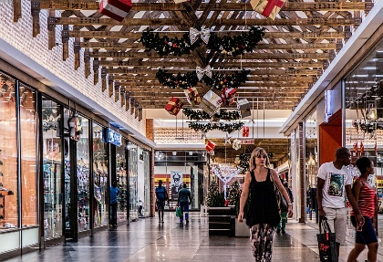**SHOPPING/BUYING THINGS**

***Looking for something in the store part 1:***

<http://www.learnenglishfeelgood.com/travelenglish/shopping-phrases-english1.html>

***Looking for something in the store part 2*** :

<http://www.learnenglishfeelgood.com/travelenglish/shopping-phrases-english2.html>

***Postcards/souvenirs :***

<http://www.learnenglishfeelgood.com/travelenglish/shopping-phrases-english3.html>

***Phrasebook for shopping questions and answers part 1 :***

<http://www.learnenglishfeelgood.com/travelenglish/shopping-questions-answers-english1.html>

***Phrasebook for shopping questions and answers part 2 :***

<http://www.learnenglishfeelgood.com/travelenglish/shopping-questions-answers-english2.html>

***Describing items Antonyms vocabulary :***

<http://www.learnenglishfeelgood.com/travelenglish/shopping-antonyms1.html>

***Name the item part 1 :***

<http://www.learnenglishfeelgood.com/travelenglish/shopping-visual-vocabulary1.html>

***Name the item part 2 :***

<http://www.learnenglishfeelgood.com/travelenglish/shopping-visual-vocabulary2.html>

***Name the item part 3 :***

<http://www.learnenglishfeelgood.com/travelenglish/shopping-visual-vocabulary3.html>

***Name the item part 4 :***

<http://www.learnenglishfeelgood.com/travelenglish/shopping-visual-vocabulary4.html>

**TRANPORTATION (TRAINS, CARS, ETC.)**

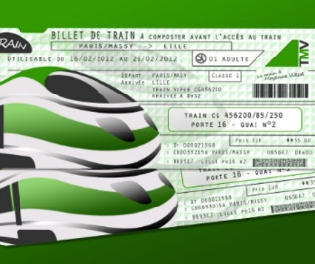

***How are we getting there ?***

<http://www.learnenglishfeelgood.com/travelenglish/transportation-types1.html>

***Buying tickets questions and answers part 1 :***

<http://www.learnenglishfeelgood.com/travelenglish/buying-tickets-questions-answers1.html>

***Buying tickets questions and answers part 2*** :

<http://www.learnenglishfeelgood.com/travelenglish/buying-tickets-questions-answers2.html>

***Buying tickets find the right answer part 1***:

<http://www.learnenglishfeelgood.com/travelenglish/english-buying-tickets1.html>

***Buying tickets find the right answer part 2*** :

<http://www.learnenglishfeelgood.com/travelenglish/english-buying-tickets2.html>

***Buying tickets find the right answer part 3*** :

<http://www.learnenglishfeelgood.com/travelenglish/english-buying-tickets3.html>

***Buying tickets find the right answer part 4 (ferry/boat)*** :

<http://www.learnenglishfeelgood.com/travelenglish/english-buying-tickets4.html>

***Trains/Taking trains what’s wrong ?*** :

<http://www.learnenglishfeelgood.com/travelenglish/trains-whats-wrong.html>

***At the gas station :***

<http://www.learnenglishfeelgood.com/travelenglish/travel-phrasebook-driving1.html>

***Driving problems*** :

<http://www.learnenglishfeelgood.com/travelenglish/english-driving-whats-wrong.html>

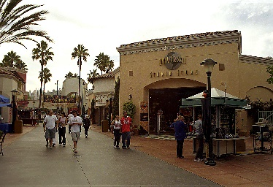**SIGHTSEEING**

***Vocabulary to visit part 1***

<http://www.learnenglishfeelgood.com/travelenglish/english-for-sightseeing-new1.html>

***Vocabulary to visit part 2 :***

http://www.learnenglishfeelgood.com/travelenglish/english-for-sightseeing-new2.html

***Vocabulary to visit part 3 :***

http://www.learnenglishfeelgood.com/travelenglish/english-for-sightseeing-new3.html

***Vocabulary to visit part 4 :***

<http://www.learnenglishfeelgood.com/travelenglish/english-for-sightseeing-new4.html>

***Vocabulary to visit part 5 :***

<http://www.learnenglishfeelgood.com/travelenglish/english-for-sightseeing-new5.html>

***Conversation while sightseeing part 1 :***

<http://www.learnenglishfeelgood.com/travelenglish/english-sightseeing1.html>

***Conversation while sightseeing part 2 :***

<http://www.learnenglishfeelgood.com/travelenglish/english-sightseeing2.html>

***Conversation while sightseeing part 3 :***

<http://www.learnenglishfeelgood.com/travelenglish/english-sightseeing3.html>

***Sightseeing questions and answers :***

<http://www.learnenglishfeelgood.com/travelenglish/sightseeing-questions-answers1.html>

***Sightseeing common terms and expressions :***

<http://www.learnenglishfeelgood.com/travelenglish/sightseeing-vocabulary1.html>

**MEETING AND TALKING TO PEOPLE**

***Meeting people when traveling part 1 :***

<http://www.learnenglishfeelgood.com/travelenglish/travel-meeting-people1.html>

***Meeting people when traveling part 2 :***

<http://www.learnenglishfeelgood.com/travelenglish/travel-meeting-people2.html>

***Talking to people : Making small talk :***

<http://www.learnenglishfeelgood.com/travelenglish/travel-talking-to-people1.html>

***Talking to people : Talking about your age, family, etc.*** :

<http://www.learnenglishfeelgood.com/travelenglish/travel-talking-to-people2.html>

***Talking to people : Saying goodbye :***

<http://www.learnenglishfeelgood.com/travelenglish/travel-talking-to-people3.html>

***Asking for directions part 1 :***

<http://www.learnenglishfeelgood.com/travelenglish/travel-phrasebook-directions1.html>

***Asking for directions part 2 :***

<http://www.learnenglishfeelgood.com/travelenglish/travel-phrasebook-directions2.html>

***Asking for directions – General terms/phrases*** :

<http://www.learnenglishfeelgood.com/travelenglish/travel-phrasebook-directions3.html>

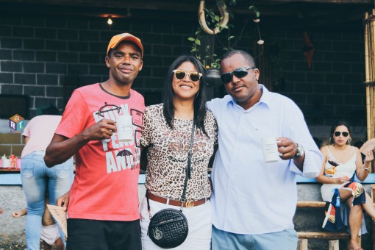

**INTERNET CAFES**

<http://www.learnenglishfeelgood.com/travelenglish/travel-internet-cafe1.html>

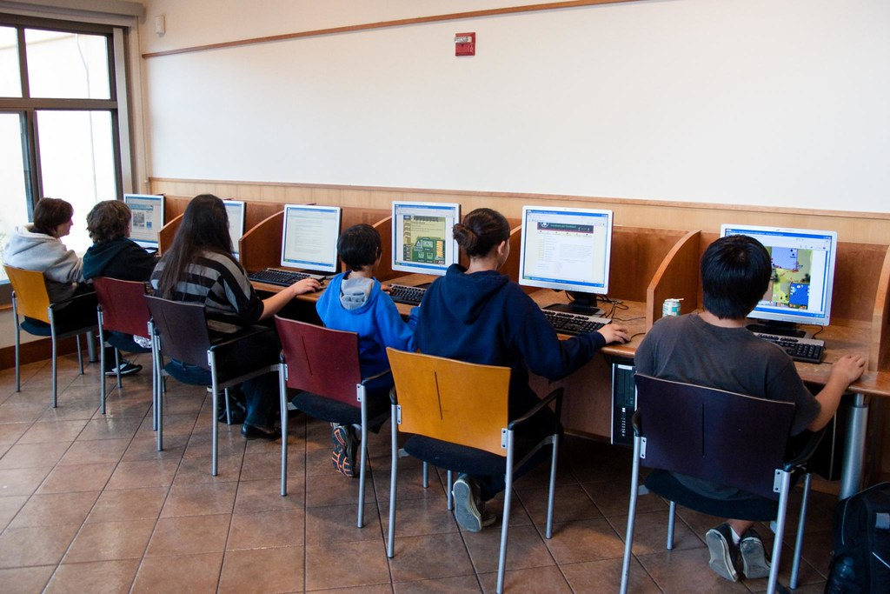

**HEALTH AND SAFETY**

***Seeing a doctor*** :

<http://www.learnenglishfeelgood.com/travelenglish/tourism-english-health1.html>

***What’s wrong*** :

<http://www.learnenglishfeelgood.com/travelenglish/english-health-whats-wrong.html>

***Safety/Crime*** :

<http://www.learnenglishfeelgood.com/travelenglish/english-safety-whats-wrong.html>

