**My Life, My Passion**

Student Booklet

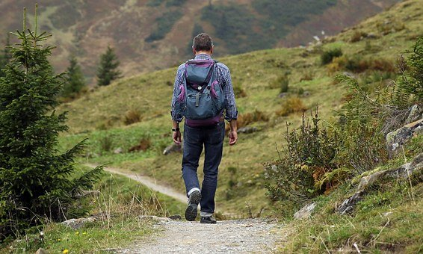

**Academic and Career Guidance Content**

Secondary Cycle Two

Knowledge of Self

**Draft of Personal Profile**: Develop a draft of a personal profile based on his/her interests, aptitudes, aspirations, and values

Name: ___________________



***Brainstorm!***

Definitions or examples of the following terms:

Personal Profile: __________________________________________________________________________________________________________________________________________________________________________________________________________________________________________

Interests:

__________________________________________________________________________________________________________________________________________________________________________________________________________________________________________

Aptitudes:

__________________________________________________________________________________________________________________________________________________________________________________________________________________________________________

Values:

__________________________________________________________________________________________________________________________________________________________________________________________________________________________________________

Aspirations:

__________________________________________________________________________________________________________________________________________________________________________________________________________________________________________

**My Life, My Passion: *Personal Profile***  
Record your interests, aptitudes, values and aspirations in the spaces below. Under each of the interests and aptitudes you have written, give an example of how they are apparent in your daily life.  
Example: I like computers. When I can, I like to try new software or figure out how my computer works.

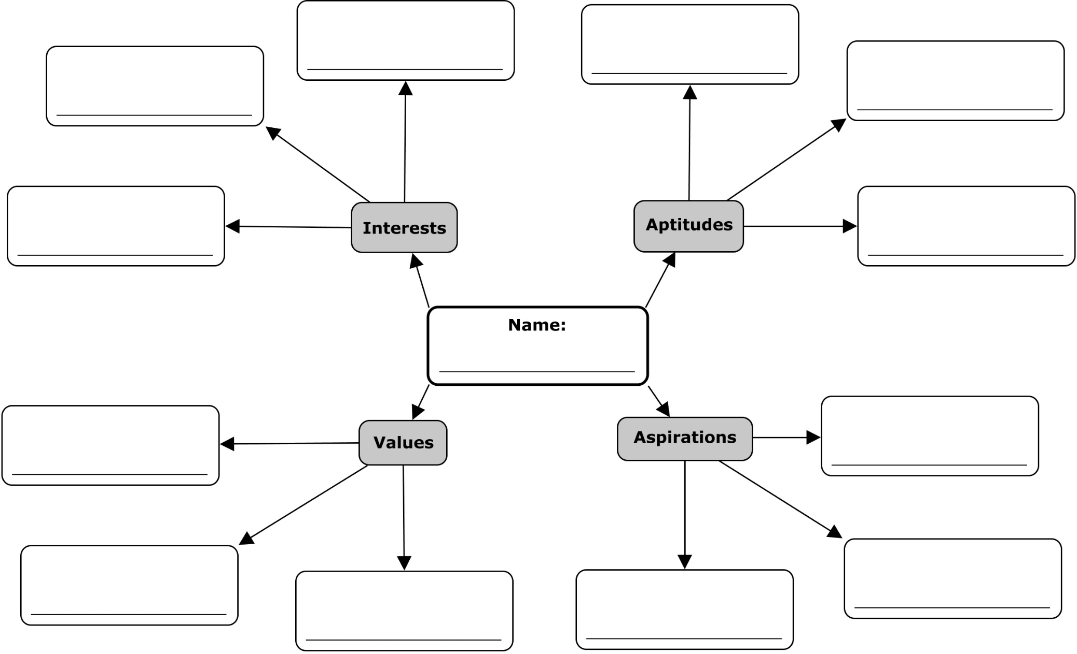

**My Life, My Passion: Student Booklet** Name: ____________________

Digging Deeper

What did you learn about your interests that you did not know before completing this activity?

__________________________________________________________________________________________________________________________________________________________________________________________________________________________________________

What did you learn about your values that you did not know before completing this activity?

__________________________________________________________________________________________________________________________________________________________________________________________________________________________________________

What did you learn about your aptitudes that you did not know before completing this activity?

__________________________________________________________________________________________________________________________________________________________________________________________________________________________________________

What did you learn about your aspirations that you did not know before completing this activity?

__________________________________________________________________________________________________________________________________________________________________________________________________________________________________________

How do your values interact with or impact your aspirations?

__________________________________________________________________________________________________________________________________________________________________________________________________________________________________________

How do your interests interact with or impact your aptitudes?

__________________________________________________________________________________________________________________________________________________________________________________________________________________________________________

How do your aptitudes interact with or impact your aspirations?

__________________________________________________________________________________________________________________________________________________________________________________________________________________________________________

How do your values interact with or impact your aspirations?

__________________________________________________________________________________________________________________________________________________________________________________________________________________________________________

**My Life, My Passion: Student Booklet** Name: ____________________

Reflect!

What did you enjoy about creating a concept map?

__________________________________________________________________________________________________________________________________________________________________________________________________________________________________________

What did you find challenging about creating a concept map?

__________________________________________________________________________________________________________________________________________________________________________________________________________________________________________

Which of the terms were easiest/hardest to define?

____________________________________________________________________________________________________________________________________________________________

What did you learn about yourself regarding your interests, aptitudes, values and aspirations?

____________________________________________________________________________________________________________________________________________________________

The learning strategy “develop” helps you integrate what you learn about yourself and helps you define your identity. How is this information helpful at this stage in your life?

____________________________________________________________________________________________________________________________________________________________

How can this information be helpful to you in the future?

____________________________________________________________________________________________________________________________________________________________